**INLUSTRO PRACTICALS**

**REACT APPLICATION MUTHURAJA M**

**813818104057**

**1. Explain the steps involved in creating News application**

Step 1: Create Project

## Step 2: Install Dependencies

The following packages will be used:

* [Redux](https://github.com/reactjs/redux/) for managing the app’s state
* [React-Redux](https://github.com/reactjs/react-redux) will be used to connect the app’s components to the redux store.
* [Redux Thunk](https://github.com/gaearon/redux-thunk) is a middleware for Redux that allows us to write action creators that return a function instead of an action.
* [Axios](https://github.com/mzabriskie/axios), a promised-based HTTP client for making calls to the API
* moment
* [React Native Elements](https://react-native-elements.github.io/react-native-elements/), Cross-Platform React Native UI Toolkit
* [React Native WebView](https://github.com/react-native-community/react-native-webview), React Native Cross-Platform WebView

## Step 3: Create Folder Structure

## Step 4: create Redux and API’s

# Step 5: create Components and Scenes

# Step 6: create Router

# Step 7: Update App.js

# Step 8: Install adb emulator from android studio and expo client to run

# Step 9: run the app in the emulator

# **2)How to call the News API? Explain with examples.**

Create a constants.js file where api infos will be stored

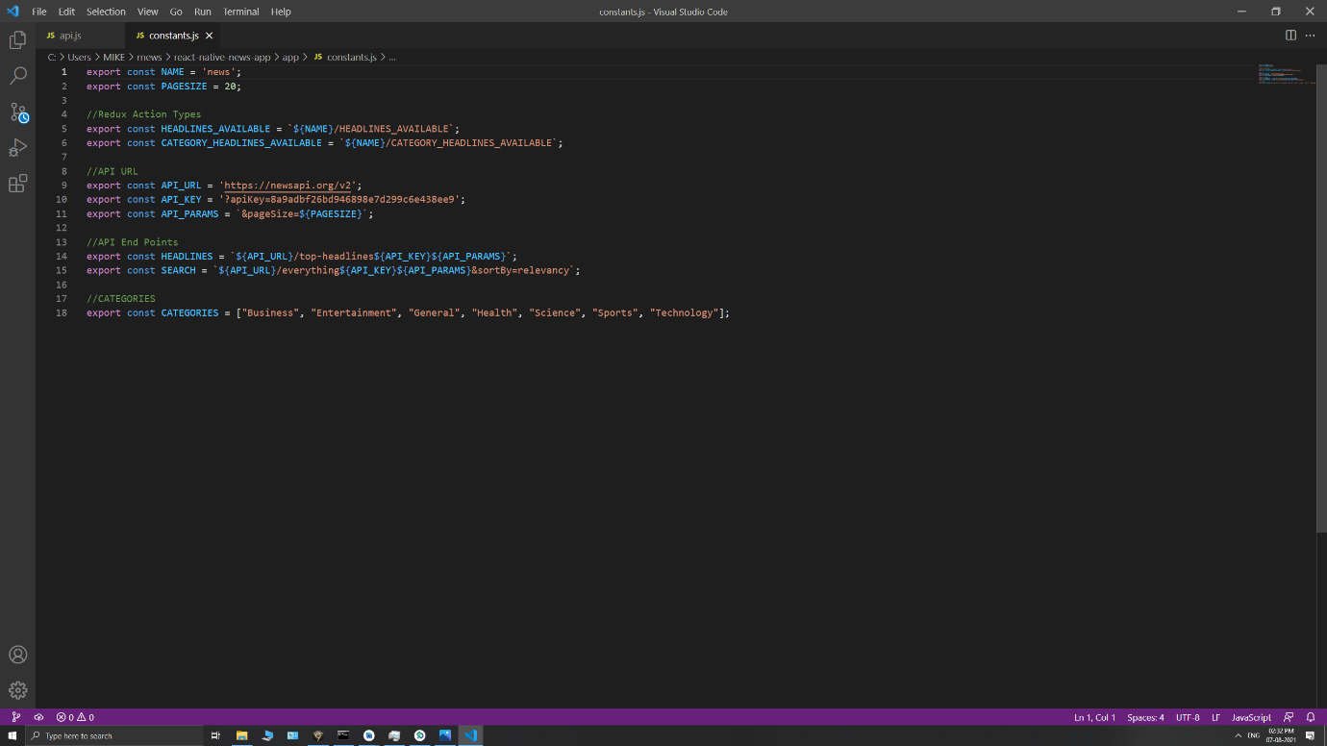

Create a api.js file to process and call the api in respective places

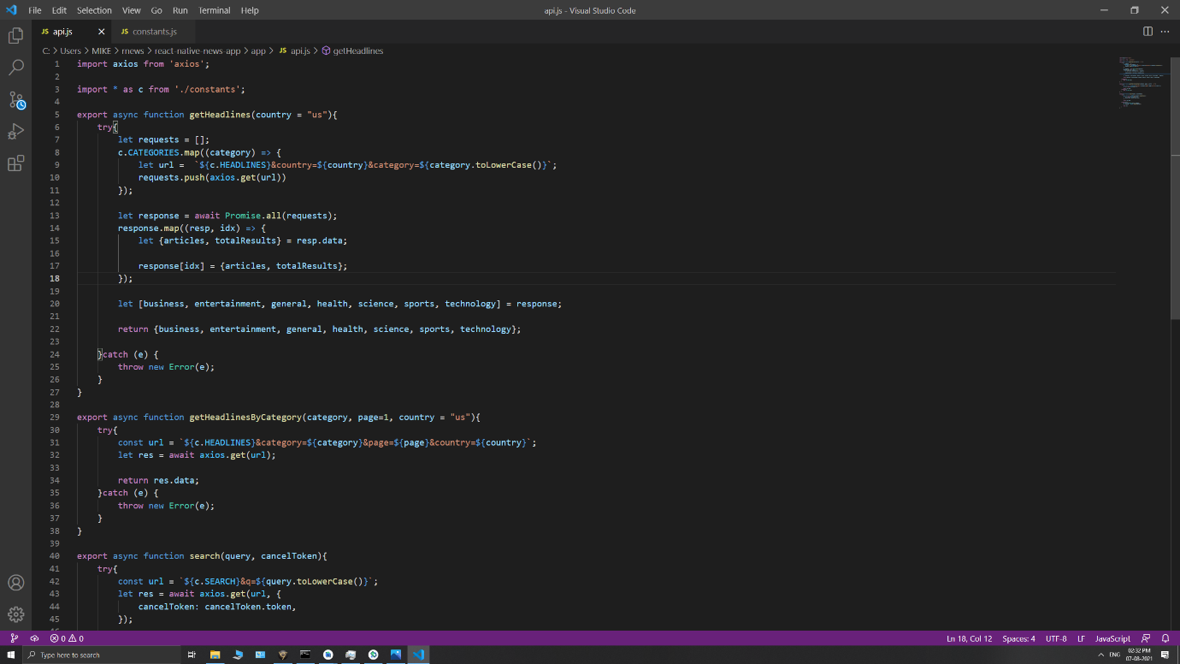

3)Steps involved in creating Light and Dark mode.

### Step 1: Setup simple screens with the React Native paper

Step 2: setup navigation

Step 3:setup redux

import React from 'react';

import { View, TouchableOpacity } from 'react-native';

import {

List, Switch,

} from 'react-native-paper';

export default ({ navigation }) => {

return (

<View style={{ flex: 1 }}>

<List.Item

title="Dark Mode"

left={() => <List.Icon icon="brightness-4" />}

right={() => <Switch />}

/>

</View>

)

}

**4)Can we combine Android or iOS code in react native? Justify.**

Yes, we can. React Native smoothly combines the components written in Objective-C, Java, or Swift.

When using React Native to write mobile apps, JavaScript is the primary programming language. Sometimes, you may want to call a platform API that is not supported by existing React Native component or use a third-party Android library For these cases, you need to write native code for bridging using Android Studio and Xcode.

**5. Share your code screenshot of the News application and explain how you have implemented it.**

Step 1: Create Project

## Step 2: Install Dependencies and expo client

## Step 3: Create Folder Structure

## Step 4: create Redux and API’s

## 

## Step 5: create constants

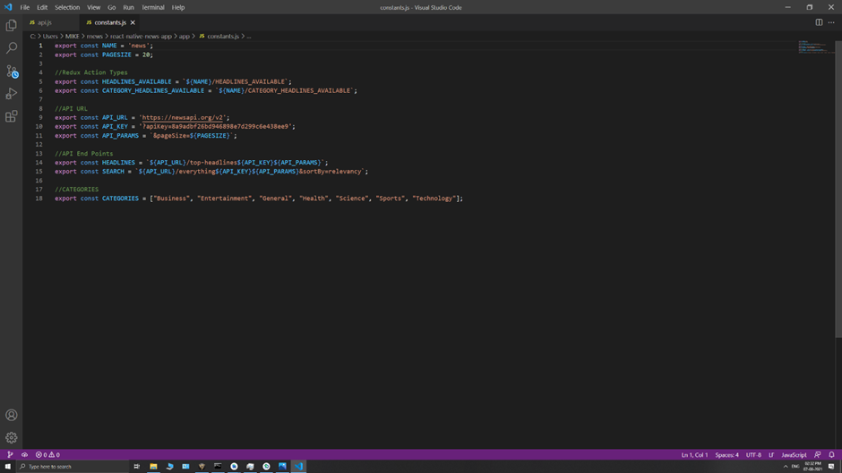

Step 6: create api

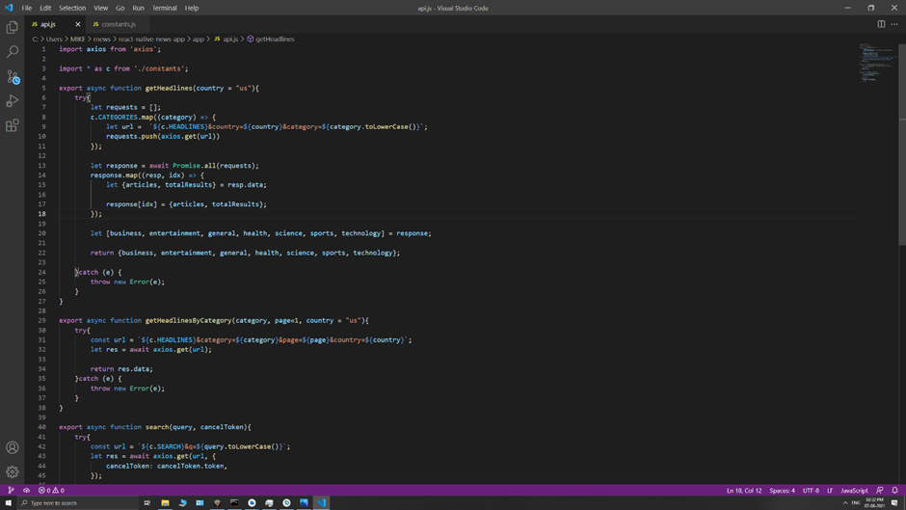

## Step 7:create Components

## Panel.js

## 

Panelitem.js

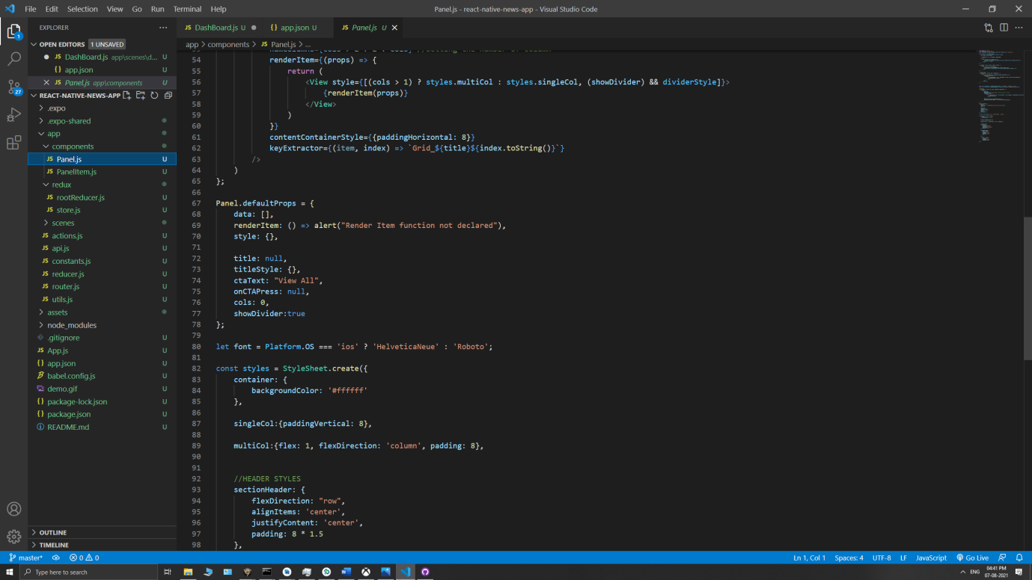

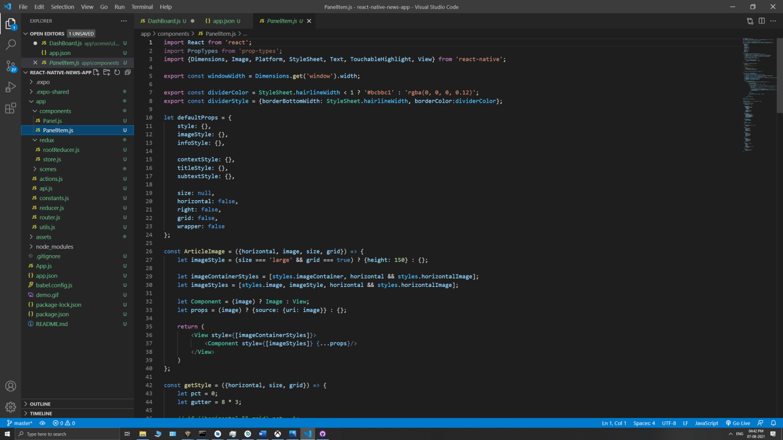

Step 8: create articles and search bar js files

Step 9: Run expo client and add android emulator

Output:

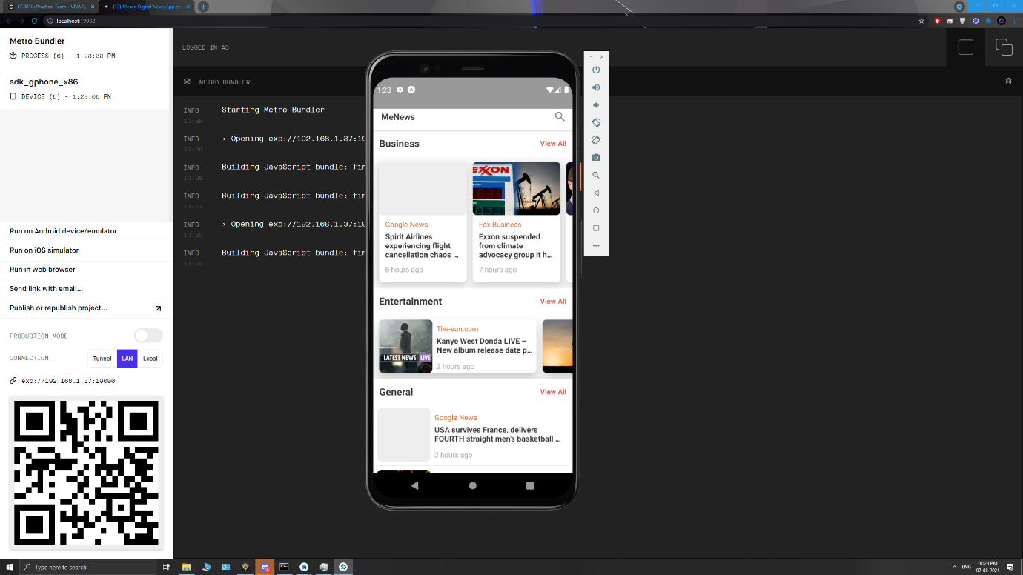

## 

## [GitHub repo link:](https://github.com/Michael-25/ReactNative-newsapp)

https://github.com/smtraja03/React-application